Theory
Schemas, Dimensions, Facts
The database schema of a database system is its structure described in a formal language supported by the database management system (DBMS). The term "schema" refers to the organization of data as a blueprint of how the database is constructed (divided into database tables in the case of relational databases).
A "fact" is a numeric value that a business wishes to count or sum. A "dimension" is essentially an entry point for getting at the facts. Dimensions are things of interest to the business
Dimension Modelling
A Dimensional Model is a database structure that is optimized for online queries and Data Warehousing tools. It is comprised of "fact" and "dimension" tables. Dimensional Models are designed for reading, summarizing and analyzing numeric information
Dimension and Fact tables
A dimension table stores attributes, or dimensions, that describe the objects in a fact table. Companion table to the fact table contains descriptive attributes to be used as query constraining. Design Should be wordy, descriptive, complete, and quality assured.
A fact table stores quantitative information for analysis and is often denormalized. A fact table works with dimension tables and it holds the data to be analysed and a dimension table stores data about the ways in which the data can be analysed. Thus, a fact table consists of two types of columns. The foreign keys column allows to join with dimension tables and the measure columns contain the data that is being analysed.
Design is defined by their grain or its most atomic level.
Star Schema
Star schema architecture is the simplest data warehouse schema. It is called a star schema because the diagram resembles a star, with points radiating from a centre. The centre of the star consists of fact table and the points of the star are the dimension tables. Usually the fact tables in a star schema are in third normal form(3NF) whereas dimensional tables are de-normalized. Despite the fact that the star schema is the simplest architecture, it is most commonly used nowadays and is recommended by Oracle.
Example of star schema:
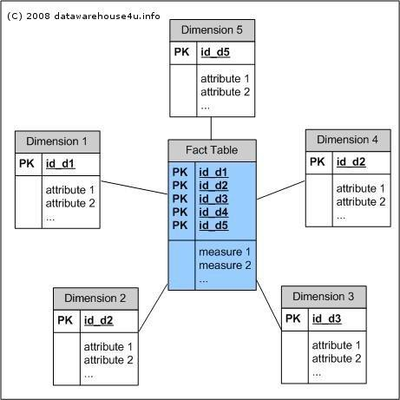

SnowFlake Schema
“Snowflaking” is a method of normalizing the dimension tables in a STAR schema. When we completely normalize all the dimension tables up to 3NF, the resultant structure resembles a snowflake with the fact table in the middle.
The snowflake schema architecture is a more complex variation of the star schema used in a data warehouse, because the tables which describe the dimensions are normalized.

Example of SnowFlake Schema:
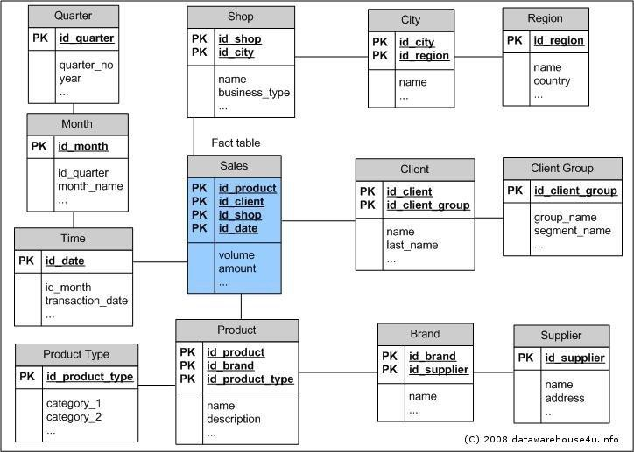
Fact constellation schema
Also known as galaxy schema, for each star schema it is possible to construct fact constellation schema (for example by splitting the original star schema into more star schemes each of them describes facts on another level of dimension hierarchies). The fact constellation architecture contains multiple fact tables that share many dimension tables. The main shortcoming of the fact constellation schema is a more complicated design because many variants for particular kinds of aggregation must be considered and selected. Moreover, dimension tables are still large. It can be seen as an extension of the star schema. A collection of multiple fact tables sharing dimension tables, viewed as a collection of stars.

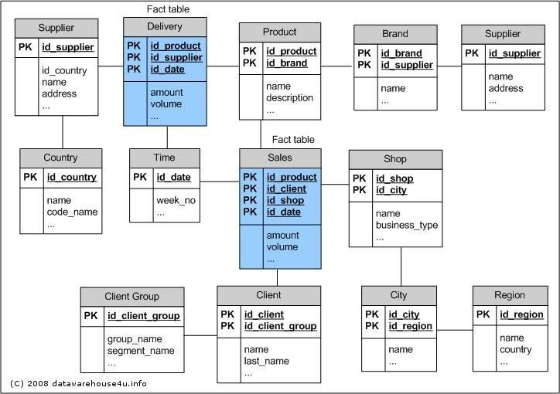

Problem definition used in this experiment
Design a star schema to track a shipments for a distribution company , the following dimension table are found
- Time
- Cust_Shipto
- ShipFrom
- Product
- TypeOfDeal
- ModeOfShipment

Review this dimension and list possible attributes for each of dimension table also designate a primary key for each table
Identifying the source tables and populating sample data
Inserting data in product dimension

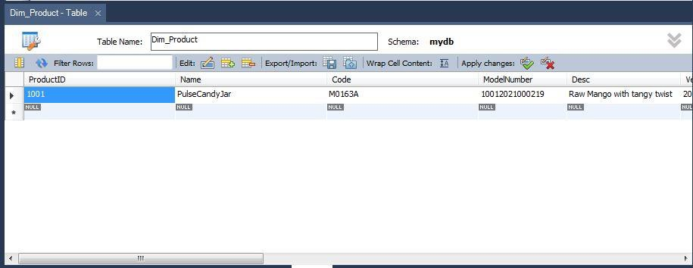

Inserting data in time dimension

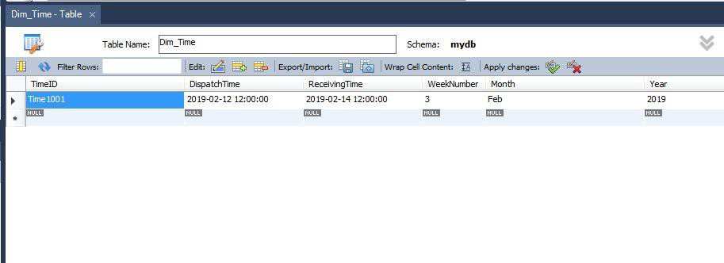

Forward engineering wizard screen initial screen
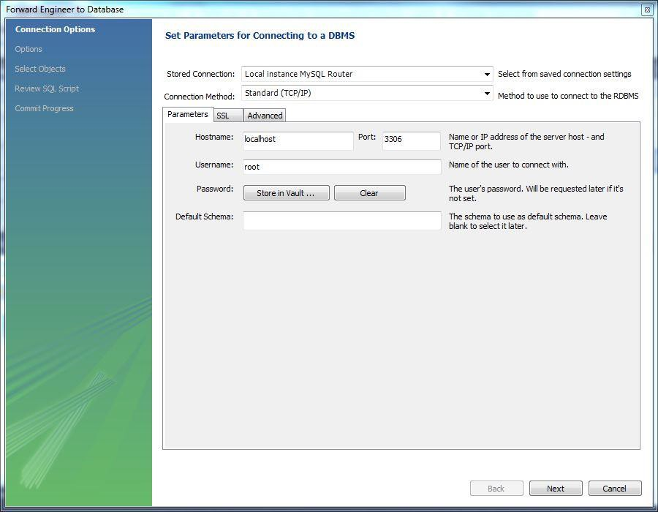
Wizard screen 2 ticking on generate insert statements

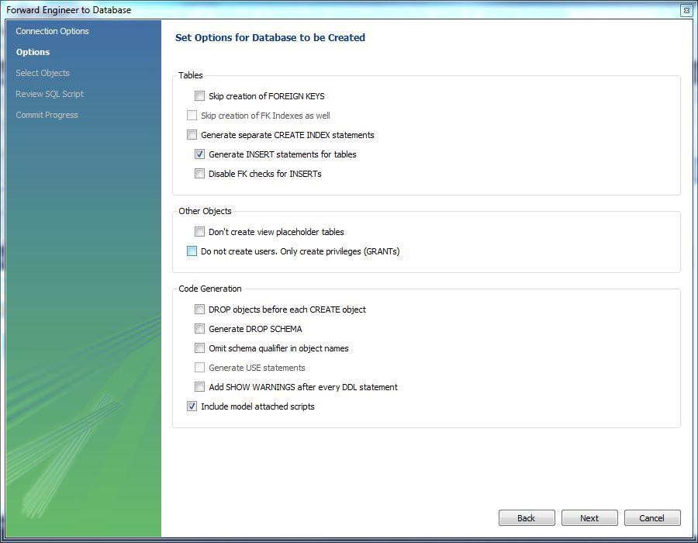

Wizard screen 3 ticking on export MySQL Table objects
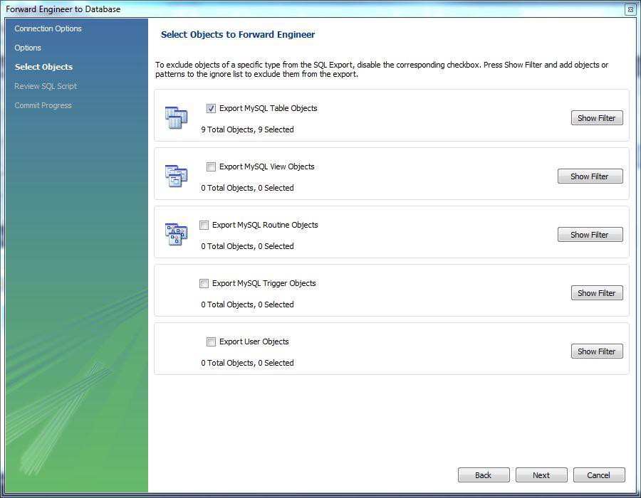
Wizard screen 4 getting a list of generated sql queries and statements

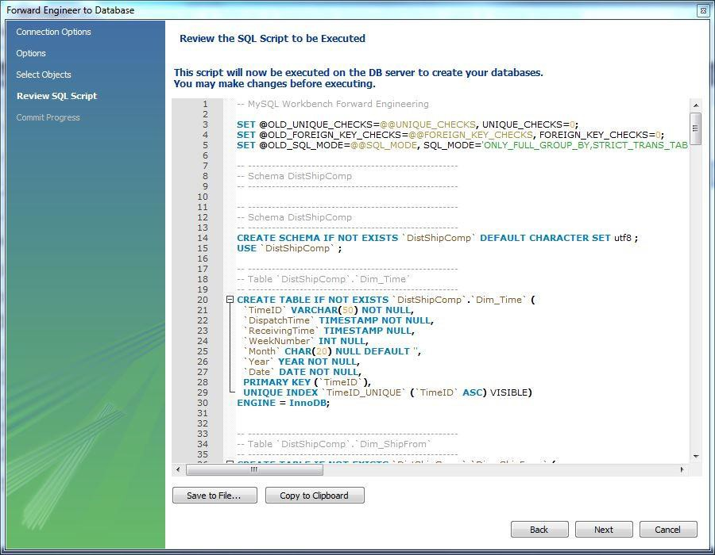

Forward engineering successfully executed

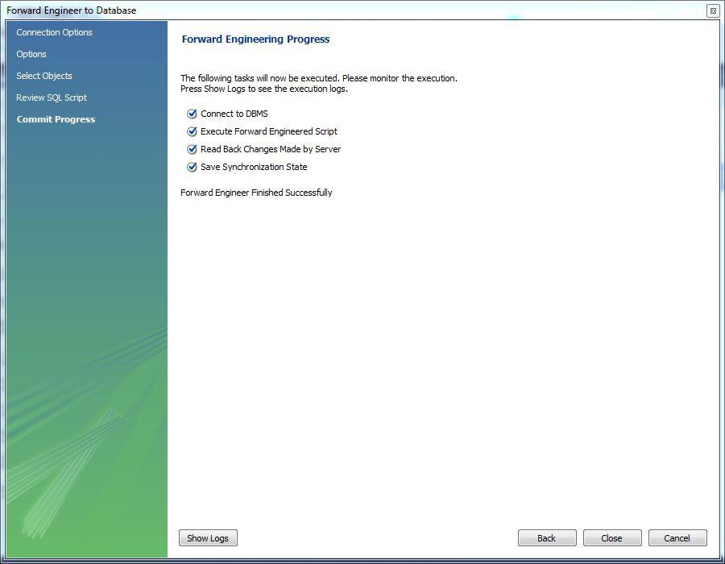
- Design dimensional data model i.e. Star, Snowflake, and Fact- Constellation schema

Star Schema for distribution company with proposed dimension

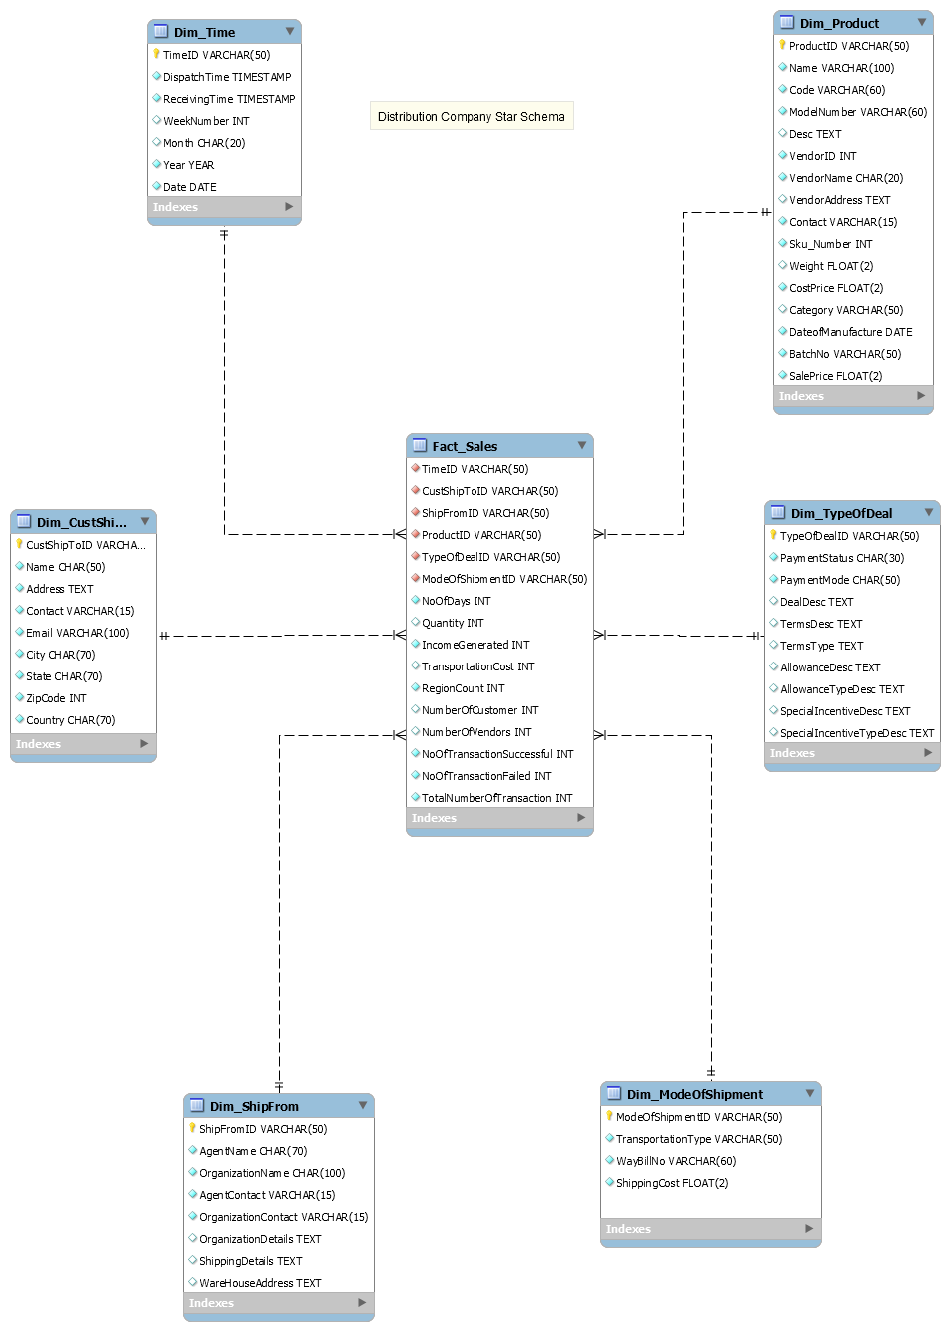
SnowFlake schema for the distribution company with proposed dimension in normalized form
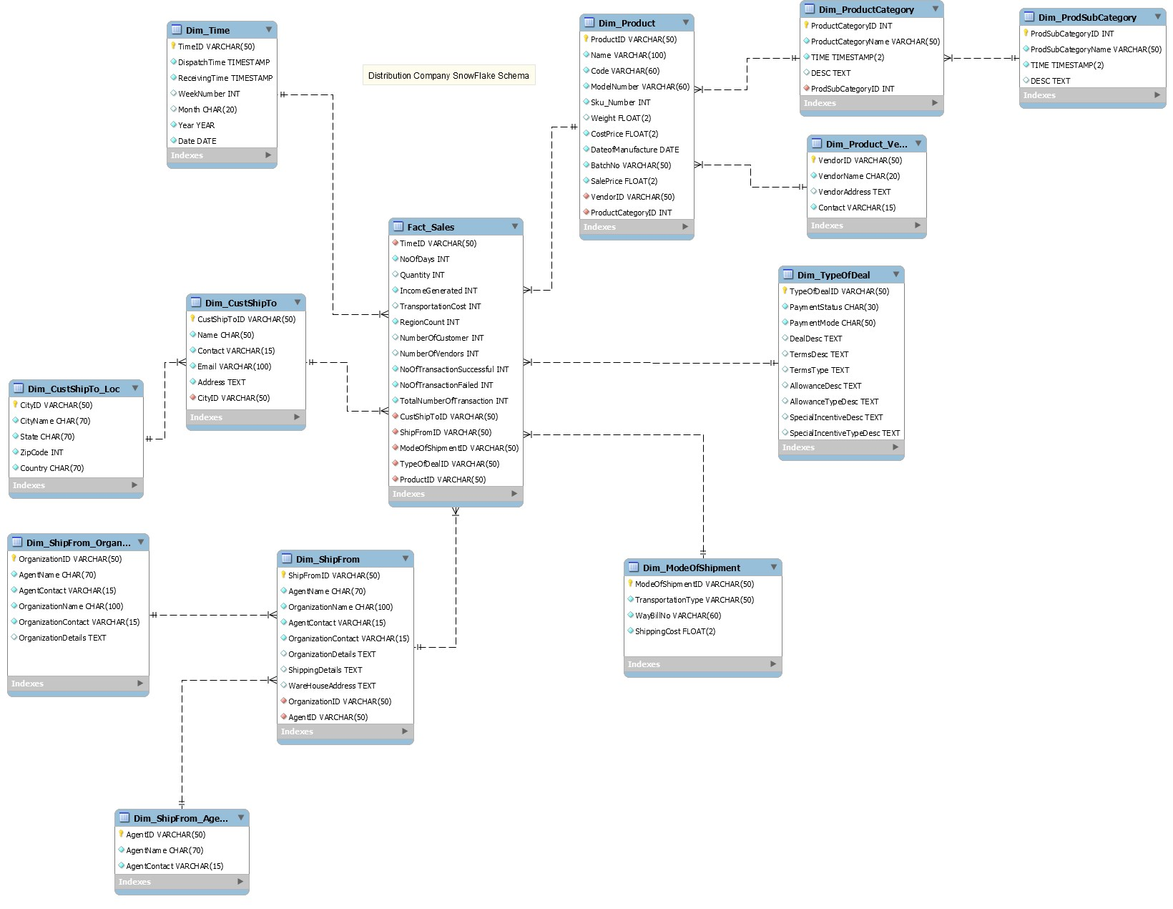
FactConstellation (Galaxy) schema for the distribution company with proposed dimension and more than 1 fact tables.
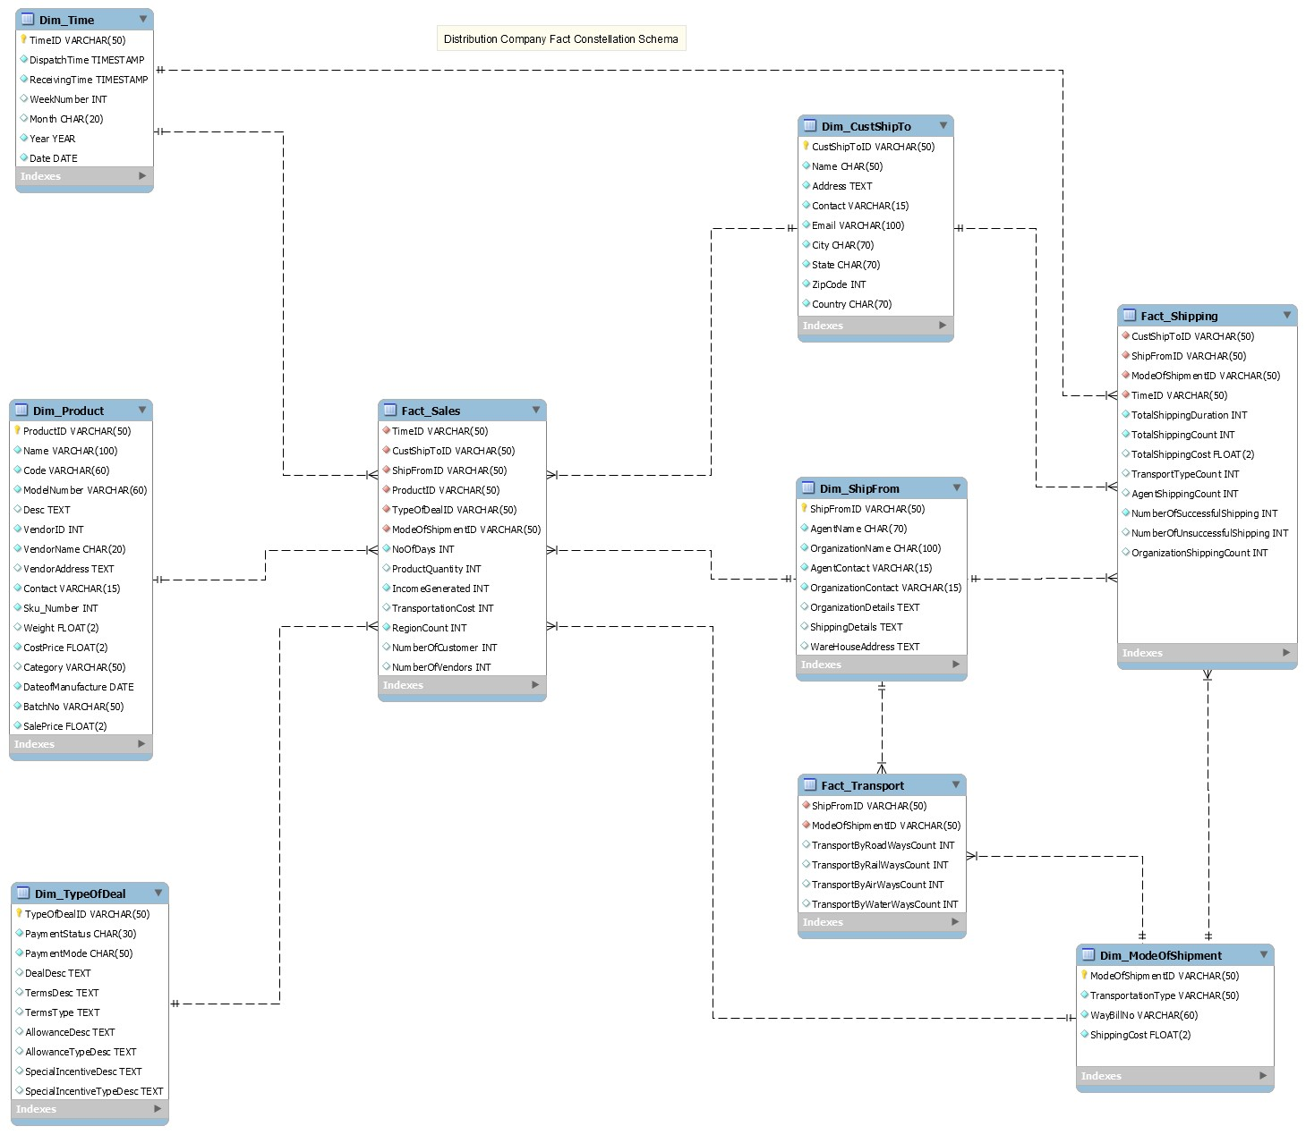

Conclusion
From i) part of this experiment we learned the basic concept about dimension modelling and were introduced with new data mart and Datawarehouse schema designing technique we have populated the sample data and shown each step prompted by wizard
From ii) part of the experiment we have implemented the given problem definition of a shipment company which ships and track products in all the three schemas first, star then we normalized it to create snowflake and, in the end, we build multiple fact tables resulting into galaxy schema

